Math 2312 - Pre-Calculus  ***Quiz***  Name _______________

*Professor*: Fred Khoury

Consider the right triangle given by:

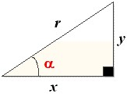

***a***) Find the following in *x, y, r*

sin α = cos α = tan α =

csc α = sec α = cot α =

***b***) if *x* = 3 and *y* = 4 *r* = ___________ and sin α =

Fill up

|  |  |  |  |  |  |
| --- | --- | --- | --- | --- | --- |
|  |  |  |  |  |  |
|  |  |  |  |  |  |
|  |  |  |  |  |  |
|  |  |  |  |  |  |